Phase 4: Data Storage & SQL Analysis - Complete Documentation

Overview
This phase involves designing, implementing, and analyzing a relational database for Olist E-commerce data. The database stores transactional data, customer information, product details, seller information, payment records, and customer reviews.

SQL Table Schema
  - Database Creation
create database olisecommerce;

Table Structures

Orders Table
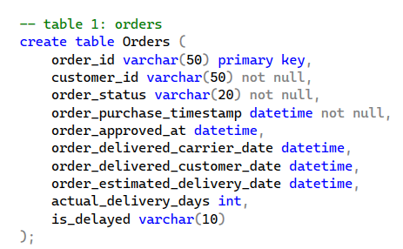

OrderItems Table (Order Line Items)
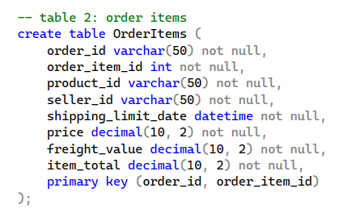

Customers Table (Customer Master Data)
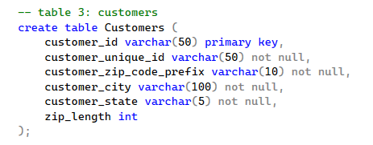

Products Table (Product Catalog)
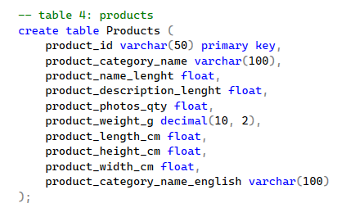

Sellers Table , Reviews and Payments
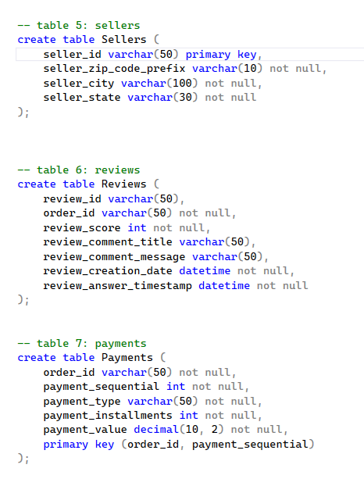

SQL Analysis Strategy

3.1 Data Filtering Analysis
Key Analyses Performed:
- Delivery Performance Analysis: Identified delayed orders to improve logistics operations
- Product Categorization: Filtered heavy electronics for shipping optimization

3.2 Metric Aggregation Analysis
Key Aggregations:
- Sales Performance by Category: Revenue, order volume, and average pricing analysis
- Geographic Performance Metrics: Customer distribution and spending patterns by region

4. Reporting Framework Implementation

4.1 Strategic Views for Business Intelligence

View 1: vw_MonthlySales
Purpose: Track revenue and order trends by month
What it shows:
- Order year and month
- Total orders per month
- Unique customers per month
- Total revenue per month
- Average order value per month
Business Use:
- Monitor monthly sales performance
- Identify seasonal trends
- Track revenue growth over time
- Calculate month-over-month growth

View 2: vw_CategoryPerformance
Purpose: Analyze product category performance
What it shows:
- Category name (in English)
- Total orders per category
- Number of unique products sold
- Total revenue generated
- Average product price
- Average customer review score
Business Use:
- Identify top-performing categories
- Find underperforming categories to improve/remove
- Understand pricing by category
- Link revenue to customer satisfaction

View 3: vw_DeliveryPerformance
Purpose: Monitor delivery efficiency by state
What it shows:
- Customer state (SP, RJ, MG, etc.)
- Total orders delivered
- Average delivery time in days
- Number of on-time orders
- Number of delayed orders
- On-time delivery percentage
Business Use:
- Identify problem regions with slow delivery
- Monitor delivery performance KPIs
- Allocate resources to underperforming states
- Set realistic delivery promises

View 4: vw_SellerPerformance
Purpose: Evaluate individual seller performance
What it shows:
- Seller ID
- Seller location (city, state)
- Total orders handled
- Total revenue generated
- Average order value
- Average review score
- Number of different categories sold
Business Use:
- Identify top-performing sellers
- Find low-performing sellers for support/removal
- Understand seller diversity (categories sold)
- Calculate seller-level KPIs

